**Decomposing Time Series Data**

Additive Model – use when magnitude of variation is constant with level of the time series.

Yt = St + Tt + Et

Multiplicative Model – use when magnitude of variation fluctuates with level of the time series.

Yt = St * Tt * Et

Separate time series into:

* Trend
* Irregular cycle
* Seasonal cycle (if exists)
* Cyclical patterns

Need to estimate to separate

For an additive model:

* Use smoothing method to estimate trend
* Conduct trial and error with smoothing parameter

Classical Decomposition – involves a moving average, m = 2K + 1. K = number of time points we go back and forth in estimating moving average.

Estimating trend cycle: consider a 2*4 moving average.

Seasonal adjustment: estimate the seasonal component and subtract the estimated seasonal component from original time series.

How does decomposition work?

1. It estimates the trend component using a moving average.
2. It then removes it from the time series.
3. Then compute the seasonal figure by averaging each time unit over all periods, then centers it.
4. Leaves the error component intact.

Classical composition is used but not recommended.

X-12 ARIMA – originated in U.S. census bureau.

* The trend estimate is available for all observations.
* The seasonal component is allowed to vary over time.
* It is robust to occasional unusual observations.
* Capable of handling multiplicative and additive models.
* Only allows for monthly and quarterly data.
* X-12 is non-parametric so it doesn’t assume a formal function

STL Analysis – more sophisticated

* Uses Locally weighted scatterplot smoothing (LOESS) to find the seasonal component
* Removes seasonal component using the LOESS estimate
* Uses a moving average to find the trend
* Removes the overall component from seasonal component and adds it to the trend

This is an iterative process. Keep removing trend and seasonal component until the trend is random.

* STL can handle any type of seasonality.
* The Seasonal component can change over time.
* The rate of change can be controlled by the user.
* Smoothness of trend-cycle can be controlled by the user.
* It is robust to outliers.
* Occasional unusual observations may affect the remainder but not the trend.
* It does not automatically handle trading day or calendar variations.
* Only provided for additive decompositions.
* You can perform multiplicative decomposition by taking logs, using STL, and then backtransforming.
* STL is available in the ‘Decompose’ package in R.

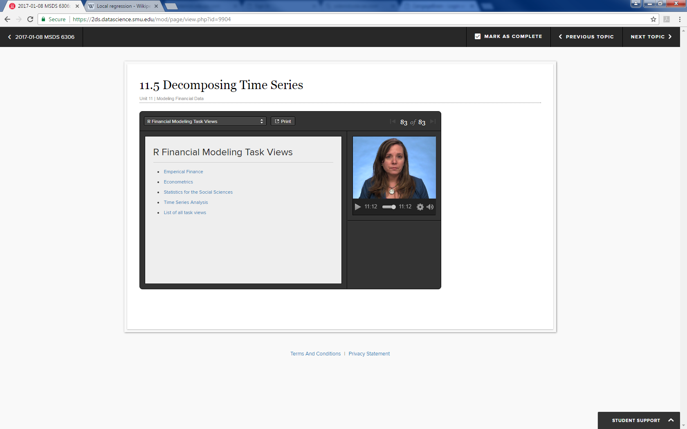

Exponential Smoothing with trends

Naïve forecast: assume only the last observation to have any information about the future is the last one. – weighted average with all of the weight on the last observation.

Average method – assume all future forecasts are equal to the average of past observations. The weighted average with equal weight on all observations. – not very useful either as future trends are very different from observations far back in time.

Simple exponential smoothing (SES): forecasts are calculated using weighted averages, where the weights decrease exponentially as observations come from further in the past.

SES has a flat forecast function. Therefore, this forecast is only suitable if the time series has no trend or seasonal component.

Initialization:

* The initial value needs to be specified.
* The weight attached to initial value is small.
* However, for a short time series, the weight may be large enough for initial value to have some influence.

Holt’s Linear Trend Method – allows for forecasting data with a trend.

Exponential trend – allows the level of the slope to be multiplied rather than added.

Linear trend – has a constant slope

Exponential trend – has a constant growth rate (exponential curve)

Damped Trend Methods

* Forecasts generated by Holt’s linear trend or exponential trend display constant trend or growth rate over the length of the forecast. In other words, they usually end up over-forecasting.
* Dampening trend methods are used to slow this constant growth down.
* There are additive and multiplicative damped parameters.
* The Multiplicative method is less conservative than the additive model.

Holt-Winters Seasonal Method

* Includes additive, multiplicative, and damped versions.
* Additive method: seasonal variations roughly constant through the series.
* Multiplicative method: seasonal variations changing proportionally to the level of the series.

Damped Method

* Often the single-most accurate forecast method for seasonal data.

**data home.unrate;**

**infile "/home/bkolovich1/my_courses/UNRATE.csv" firstobs=2 dlm=',';**

**informat date mmddyy10.;**

**format date mmddyy10.;**

**input date unrate;**

**run;**

**data unrate_cond;**

**set home.unrate;**

**where year(date) <2009;**

**run;**

**proc sgplot data=home.unrate;**

**series x=date y=unrate / lineattrs=(pattern=dash);**

**run;**

**proc esm data=unrate_cond out=unrate_forecast print=(ESTIMATES FORECASTS)**

**lead=96 plot=(MODELFORECASTPLOT);**

**id date interval = month;**

**forecast unrate / model=double;**

**run;**